Trent Banfill

4/19/21

Read 01: How to Use System Restore

Essentially the system restore tool allows the user to revert back to a previous software, registry and driver configuration called a restore point. An example of this would be you have a restore point that was established on April 19 and on April 20th you get a virus because you are looking up websites about 4/20 and doing some shady stuff. So this virus slows your computer down and you have pop ups and you want to get rid of the virus and bring your computer back to the glory of April 19th. You are able to go into your system restore settings and wind back the clock to your last restore point or even a further back restore point in case you really liked where your computer was at a couple months ago.

The System Restore settings are very easy to find, control panel>system and security>select system>system protection>(ensure you are on system protection tab)click system restore>next>select a restore point>next>Finish. It's that simple to set up and designate a restore point. After you restart your computer you are hopefully back to your restored well working restore point and it fixed your computers underlying problems. Another good tip is to make sure that your computer is in the most up to date software, which can easily be found by typing “check for updates” in your windows search bar and following the easy instructions.

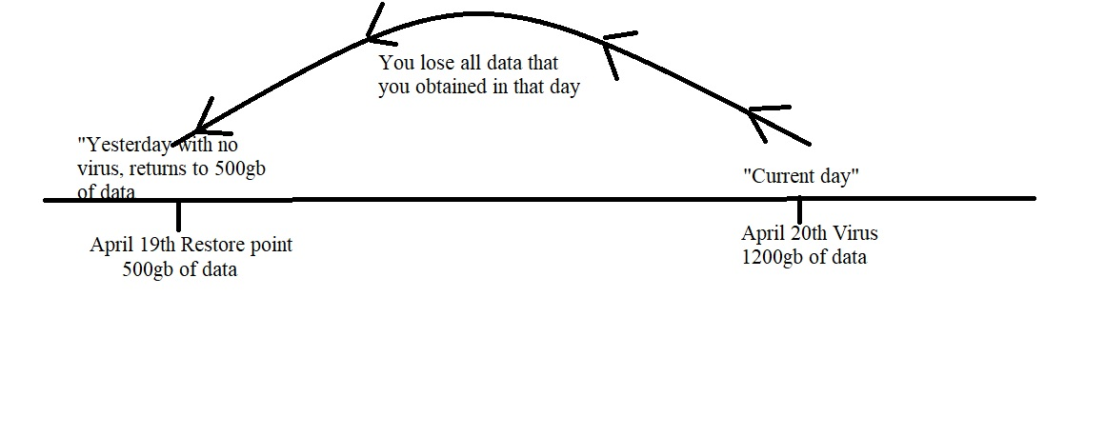

**Key Terms/Cheat sheet**

* Restore point = an image of your system configuration and settings, like programs installed or cookies accepted, etc… (you can have your computer setup to automatically do this during important updates or program installs)
* System Restore = undo/reverse changes in windows
* Check for updates = an important screen that tells you if you are up tp date on your software (you can set this to auto, so your computer will do it for you)
* Software = the programs and other operating information used by a computer. If you have out of date software a restore point won’t help you, you need to “check for updates”
* Admin/Administrator = is the system administrator, meaning they have full access to the computer and its software. Access to add/remove programs and other programs that have a major impact on how the computer operates.

**Quiz**

* Where do I find System Restore Settings in the control panel?
  + Network and Internet
  + User Accounts
  + System and Security
  + Programs
* What is a Restore Point?
  + A place to buy upgrades
  + An image of your system configuration and settings
  + Where you reset your computer to factory settings
  + Turns the fans up to clear out dust inside your computer
* There is no place to find updates on my computer, so I have to go out and buy them.
  + True
  + False
* What is Software used for?
  + Programs and other operating information used by the computer
  + Wires, Plugs and other gadgets used to run the computer
  + Padding for the motherboard to sit on
  + It’s a TopSecret wire only the Government can use
* Microsoft windows and Macintosh software use the same System Restore settings OS.
  + True
  + Flase

**Fill in the blank worksheet**

* ______________is used to undo/reverse changes done in windows.
* Programs and other operating information used by a computer is called ____________.
* Because I am the __________ I have access to add/remove programs and I can add profiles to the OS.
* I updated a _____________ today so after I install this questionable program I know I can return to my preferred settings.
* I can have multiple Restore Points saved in my System Restore settings. This statement is __________.